

**East West University**

**Department of Computer Science and Engineering**

**Summer 2025**

**Course Code:** CSE412

**Course Title:** Software Engineering

**Section – 01**

**Lab Report 04**

**Submitted to –**

**Name :** Nishat Tasnim Niloy

**Designation:** Lecturer

Department of CSE

East West University

**Submitted by –**

**Name:** Jannat Milky

**Id:** 2023-1-60-042

**Date of Submission: 17 July, 2025**

**1.1 Creating a GitHub Account**

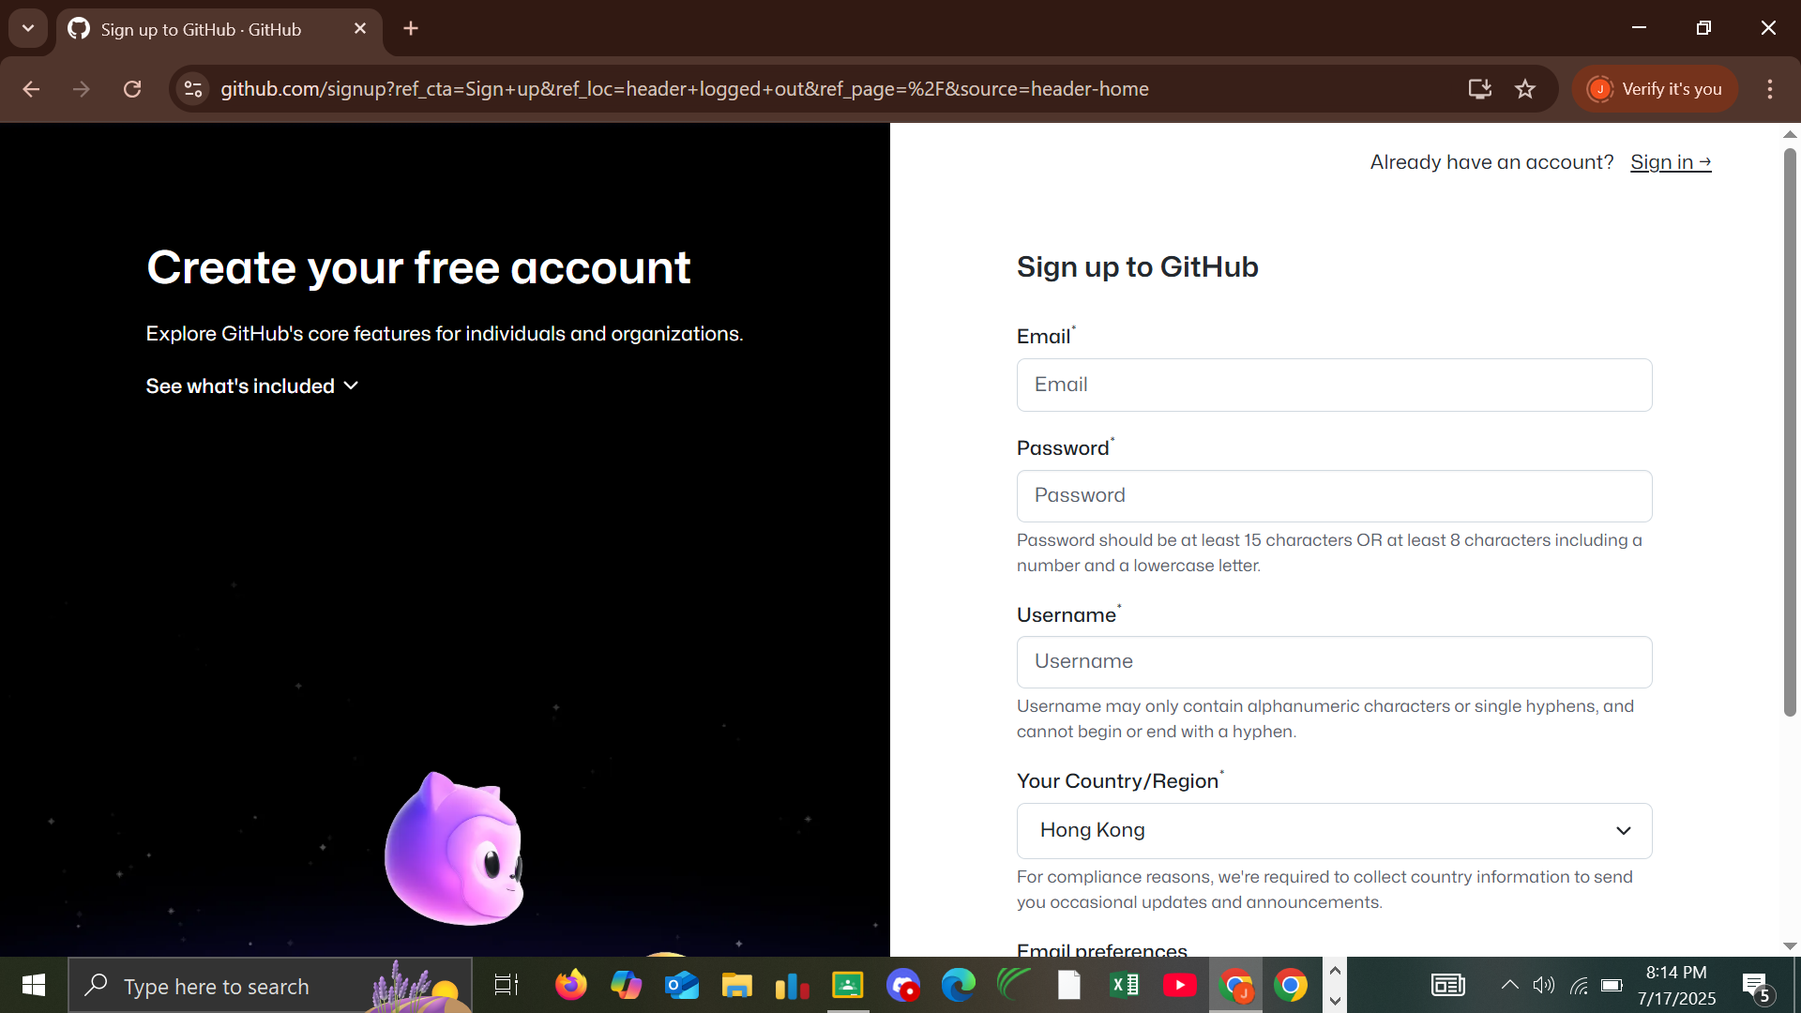

**1.2 Exploring the Dashboard**

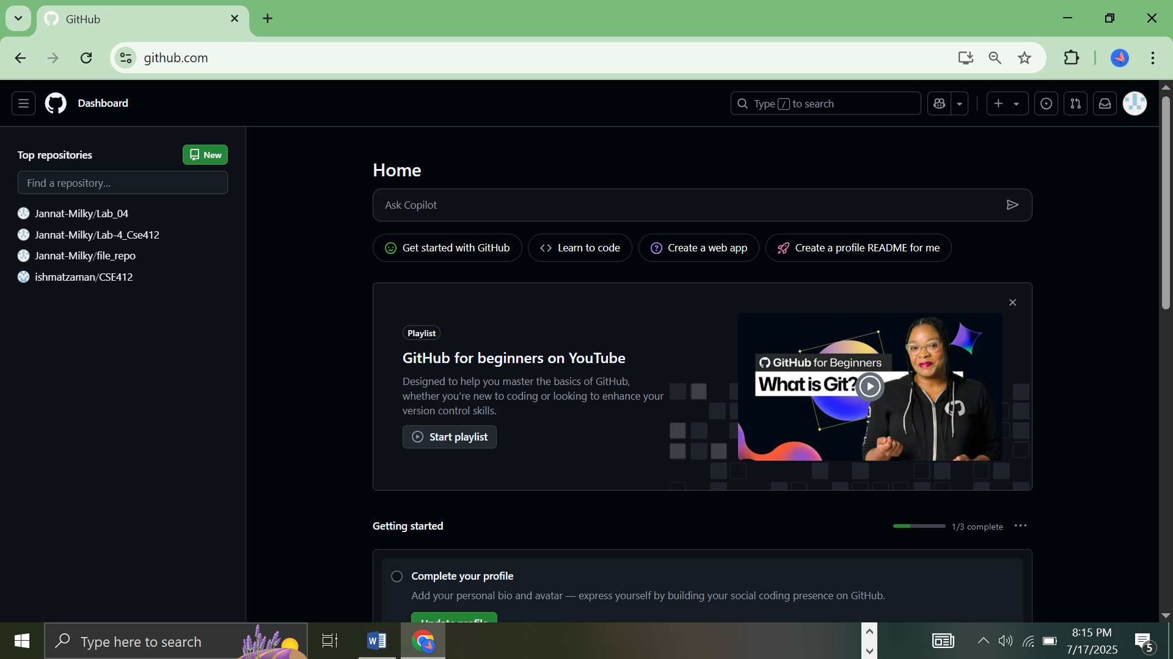

**2. Creating and Managing Repositories**

**2.1 Creating a New Repository**

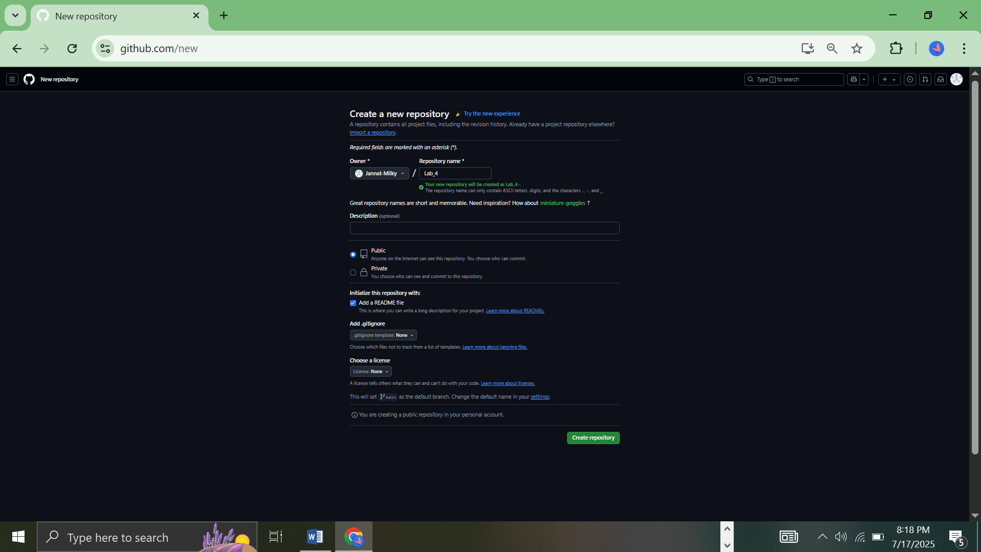

**3. Adding and Managing Files**

**3.1 Uploading a File**

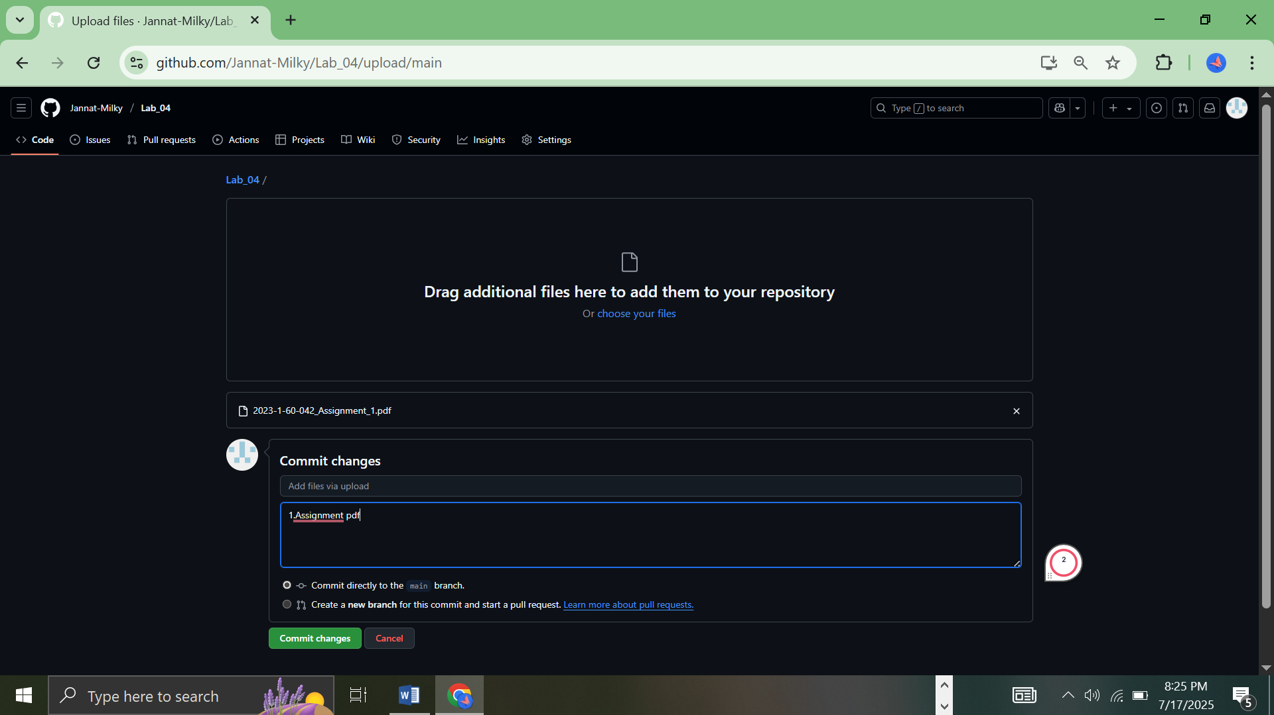

**3.2 Creating a New File**

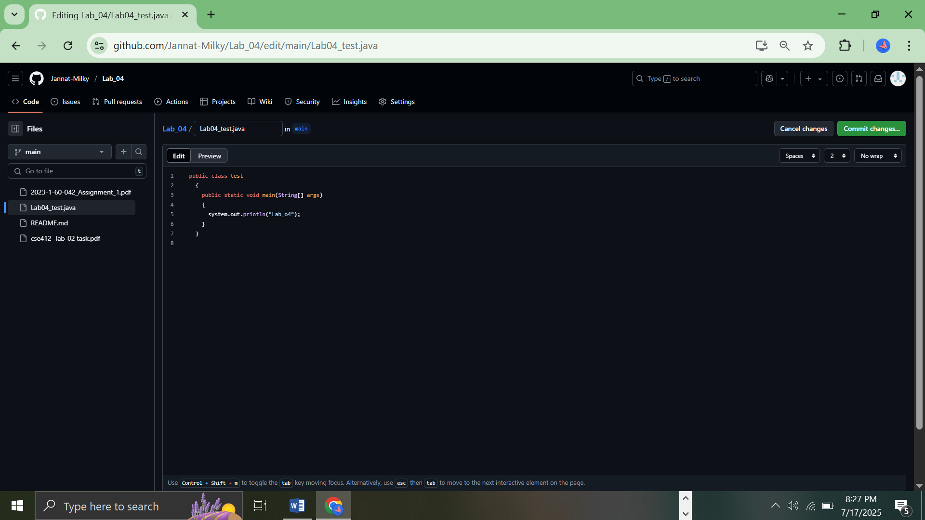

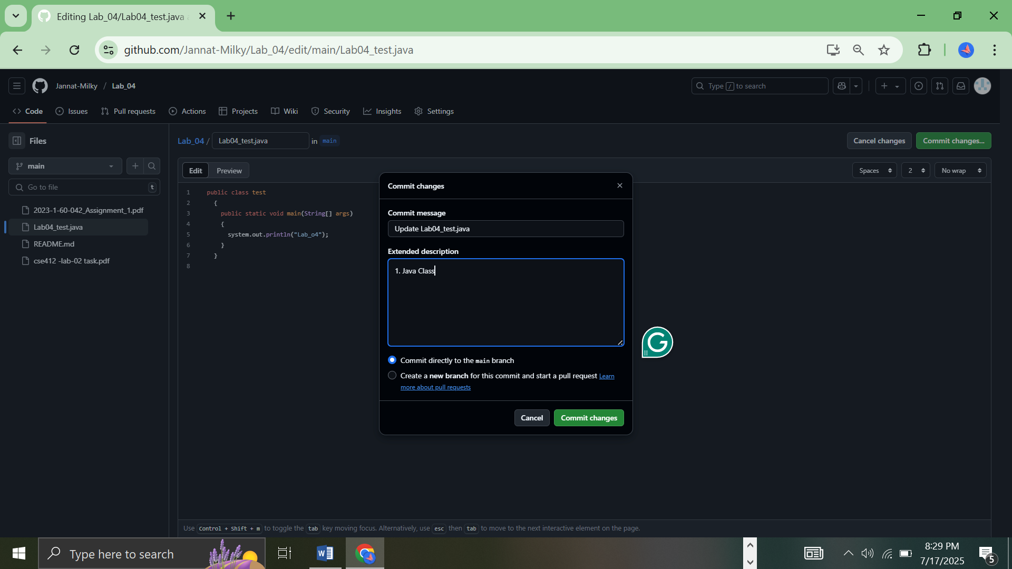

**4. Branching in GitHub**

**4.1 Creating a New Branch**

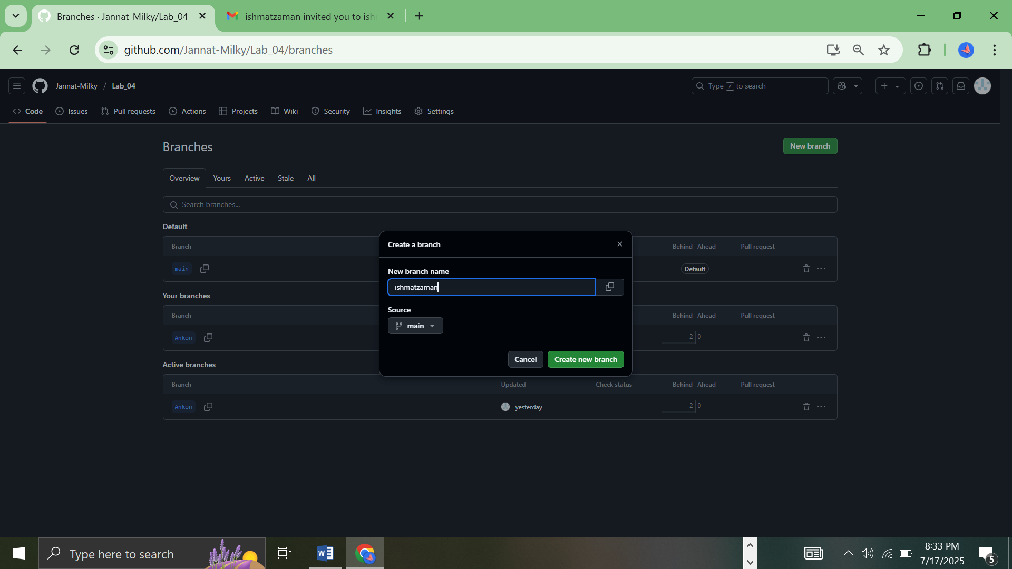

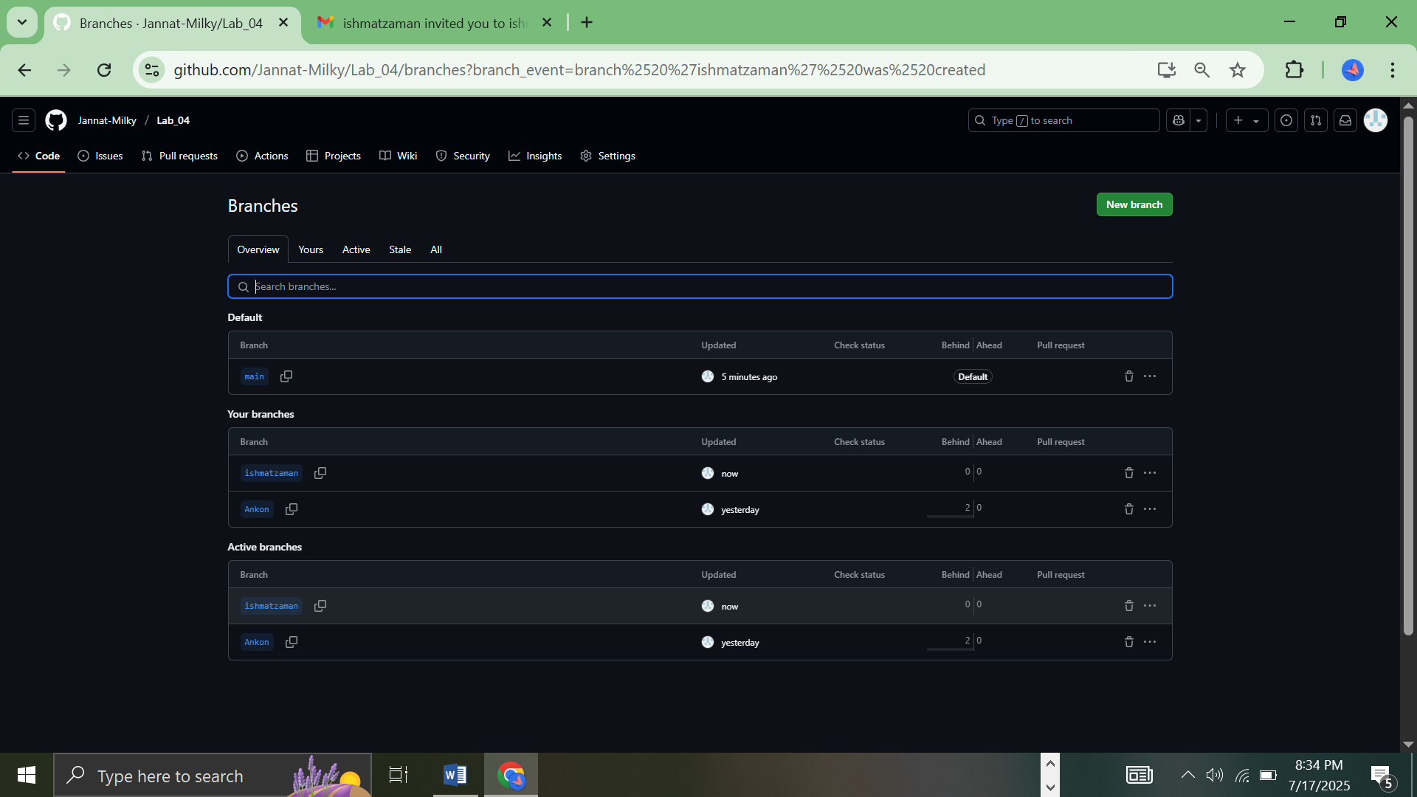

**4.2 Switching Branches**

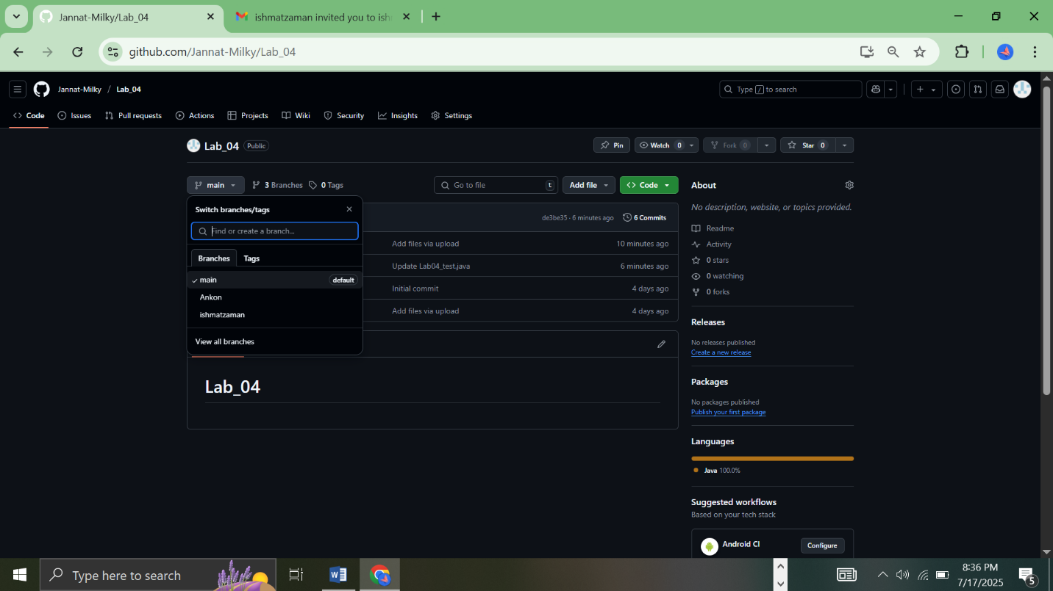

**4.3 Merging a Branch (Using Pull Requests)**

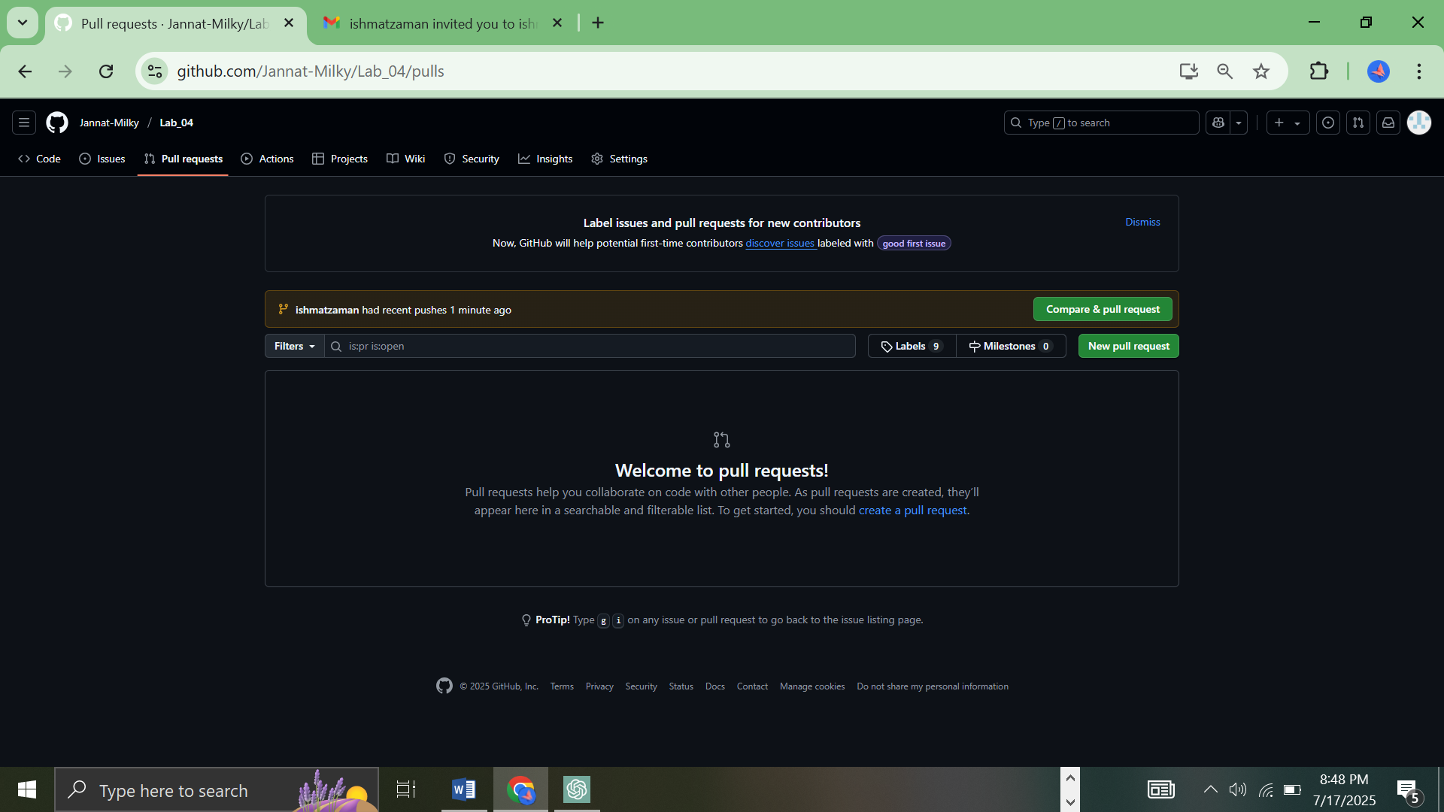

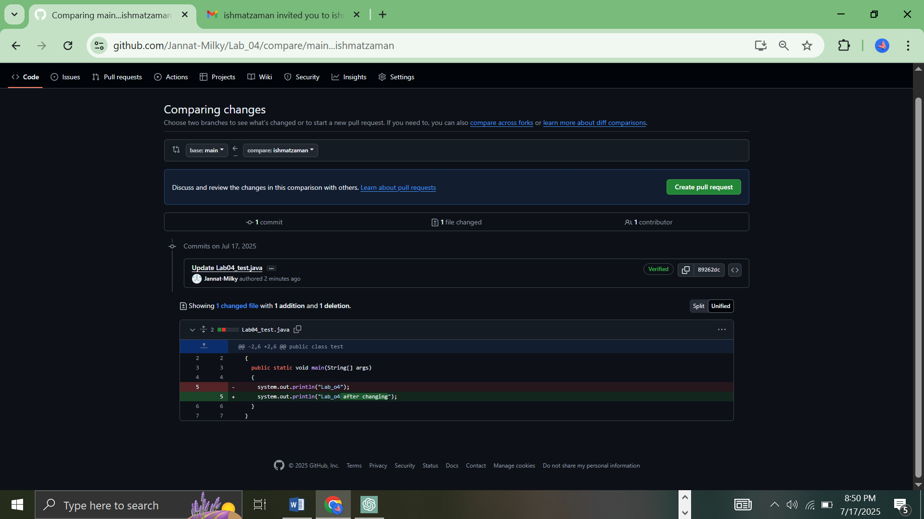

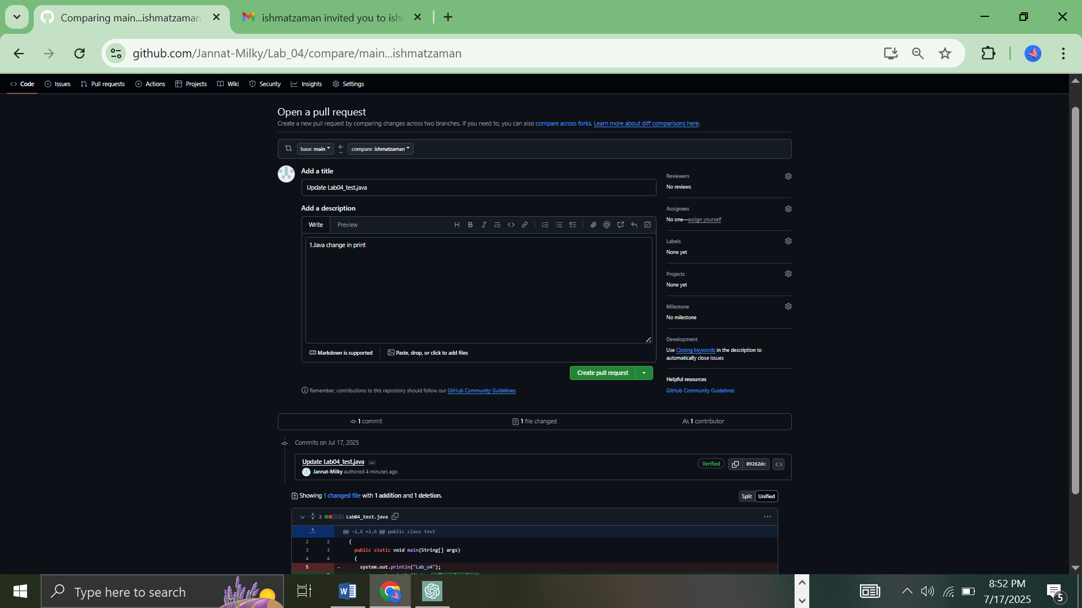

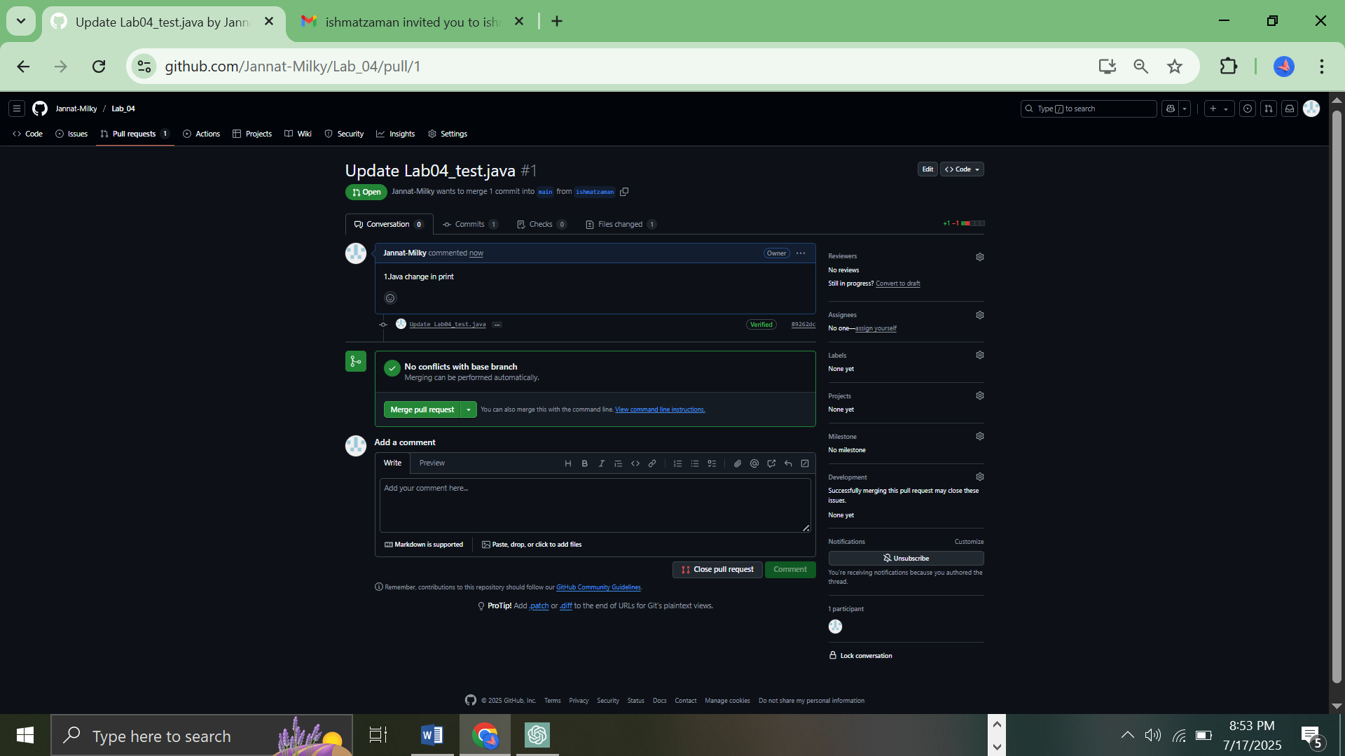

**4.4 Deleting a Branch**

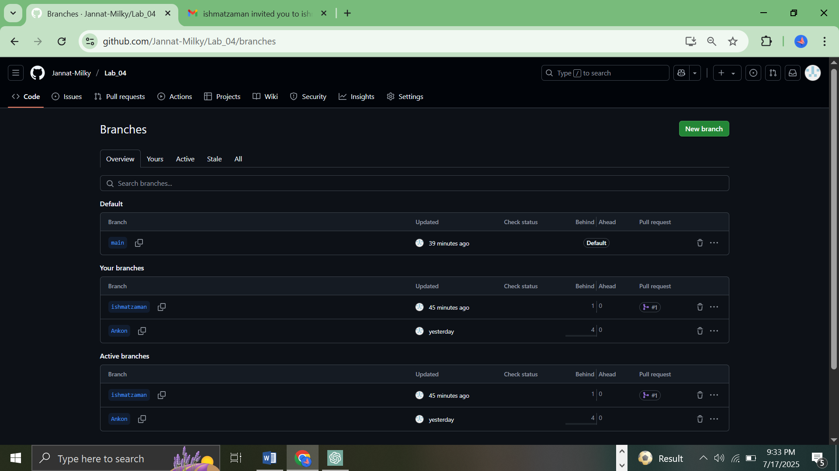

**5. Working with GitHub Features**

**5.1 Adding Collaborators**

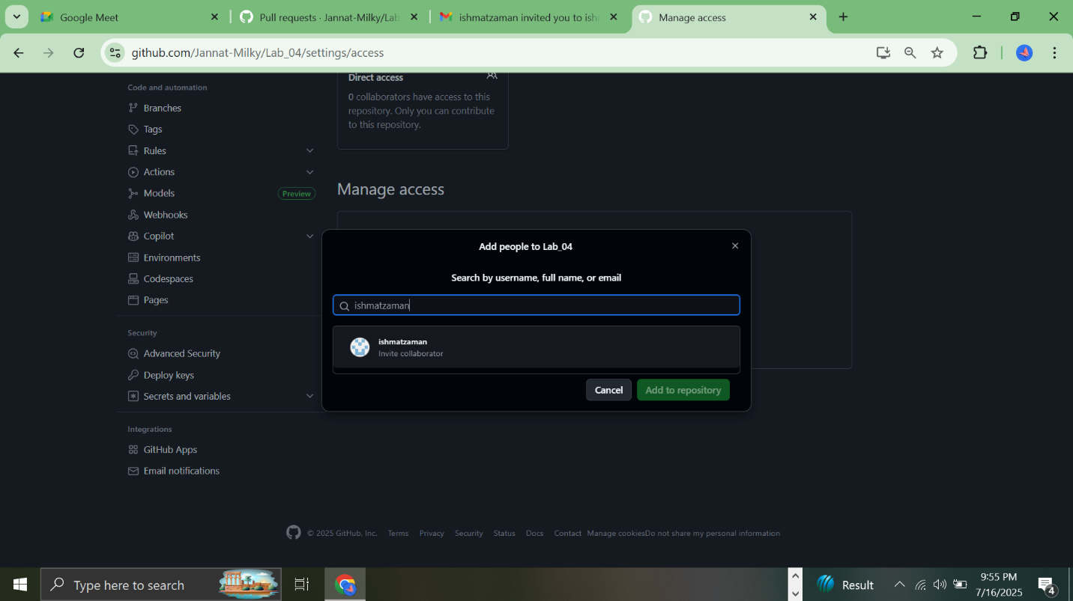

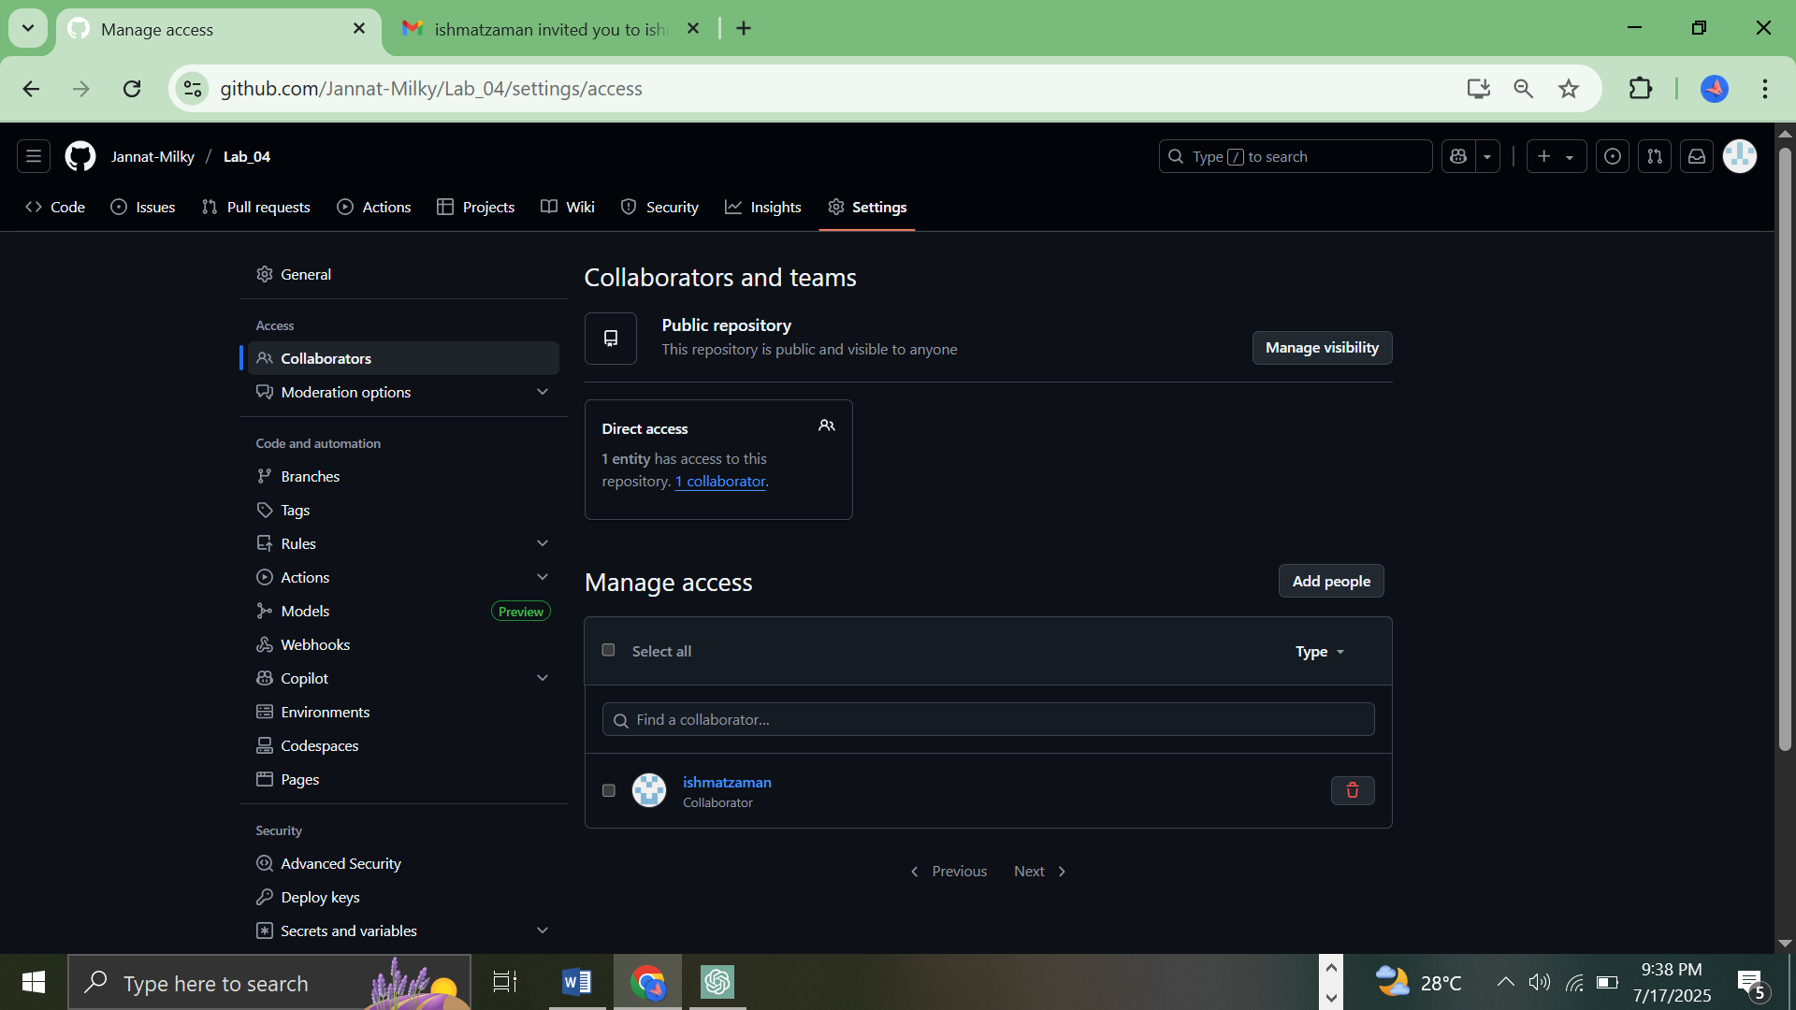

**5.2 Creating an Issue**

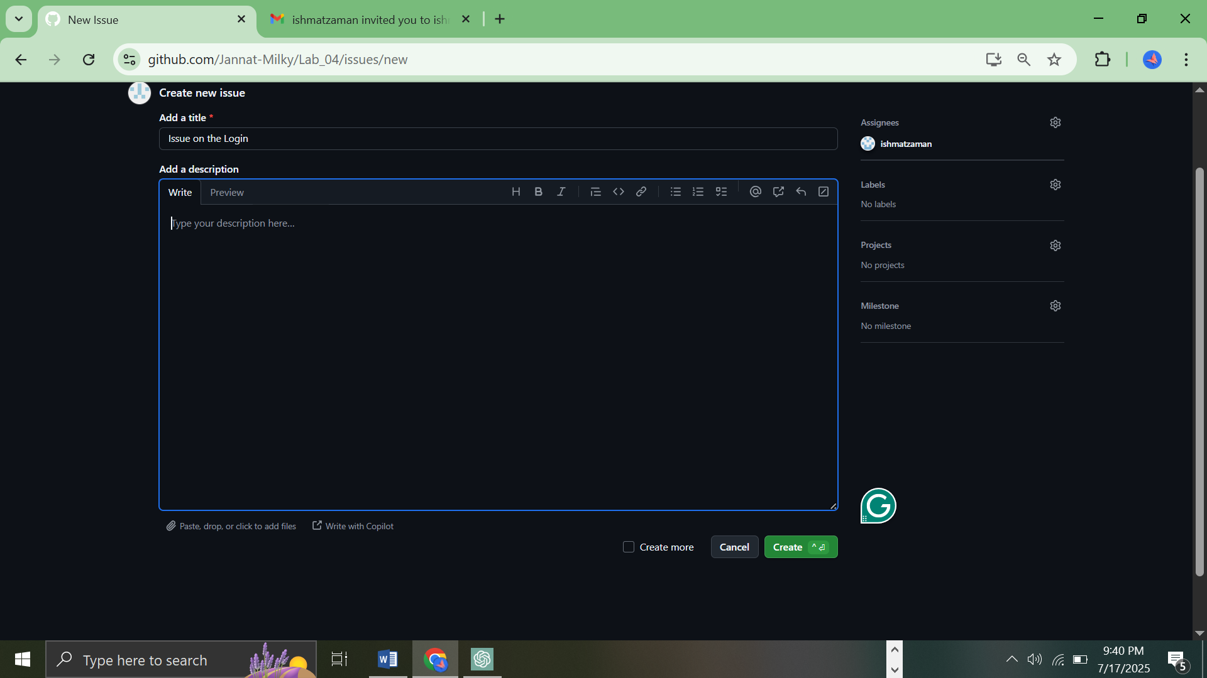

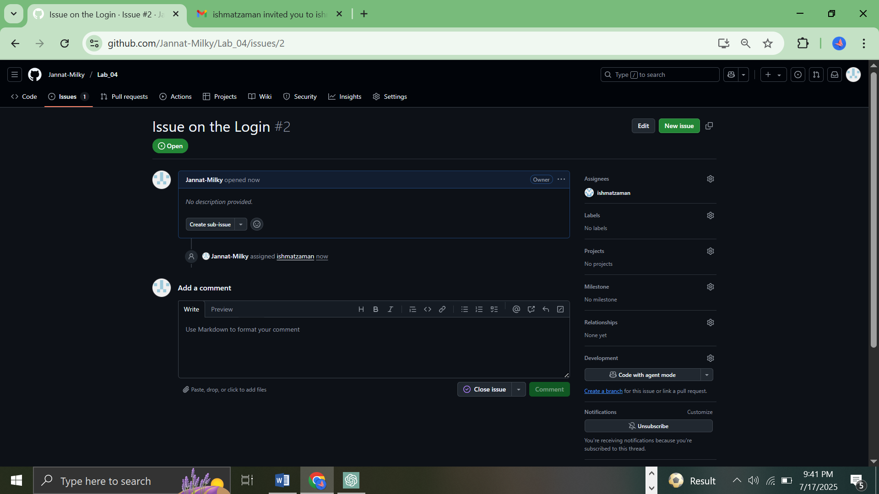

**Using CMD Interface**

**1.Creating a File to Track and Checking Git Status**

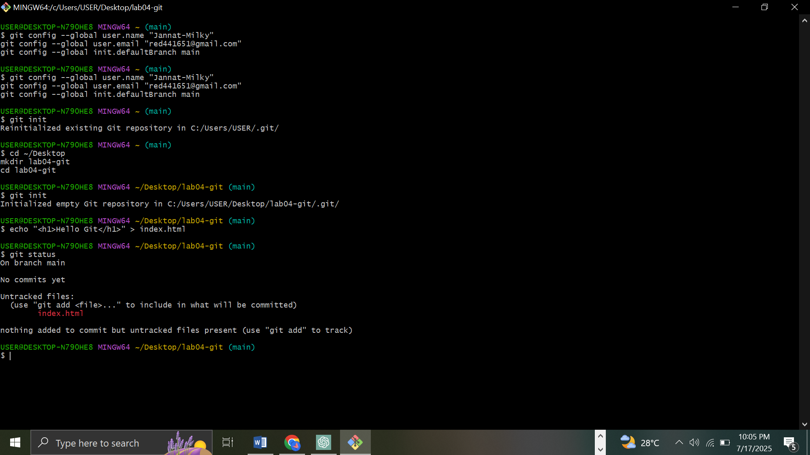

**2. Git status showing index.html staged**

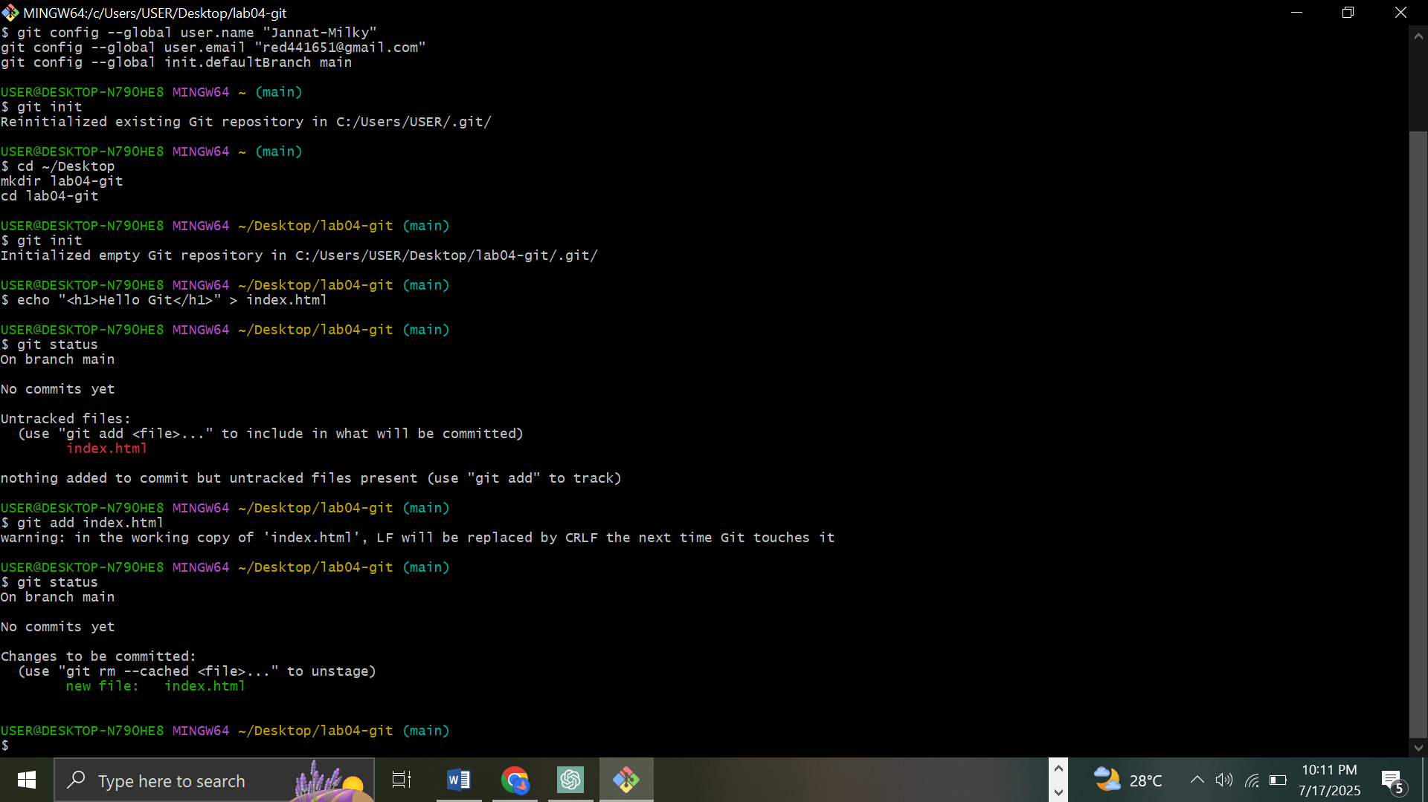

**3. Commit success message**

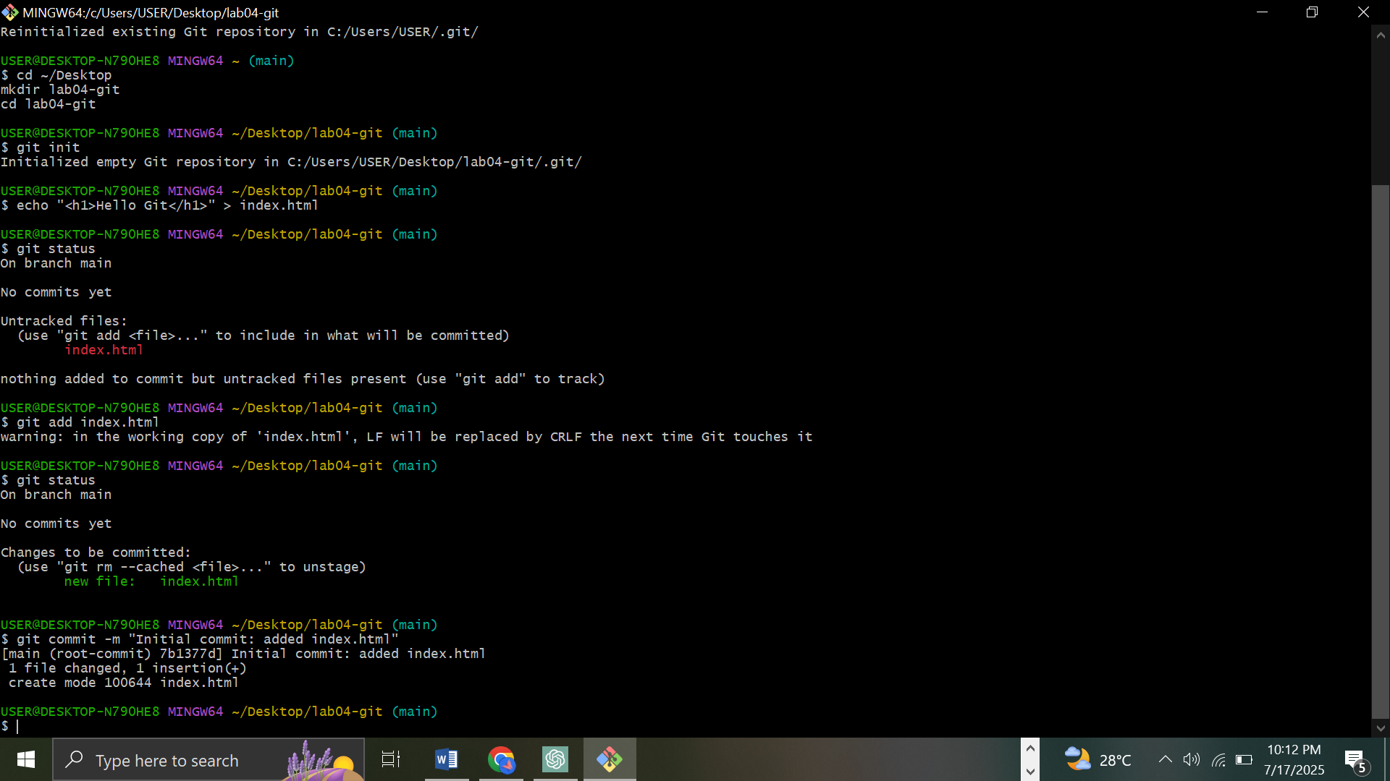

### 4. View Commit History

